AN INTRODUCTION TO CLASS BLOGS



A PROFESSIONAL DEVELOPMENT SERIES FOR MIDDLE SCHOOL TEACHERS

By: Ralph Gallo

AGENDA

This professional development series will begin with four weekly mini-sessions (towards the beginning of the school year). This will be a practical and hands-on experience for all involved. Each session will be conducted in the computer lab, with teachers participating at computer workstations. Additionally, as the year goes on, there will be monthly user group meetings (online) to discuss, support, and enhance the topics covered during the four initial sessions.

SESSION 1: INTRODUCTION AND SET-UP
Length – 30 minutes
Discussion Topics: Introductions. What is a Blog? Why use one?
Activities: Review of step-by-step guide. Blogger.com registration and template selection.

SESSION 2: CREATING CONTENT
Length – 30 minutes
Discussion Topics: Brainstorming. Subject specific blog topics. Possible class extensions.
Activities: Online research. Posting your first blog topic.

SESSION 3: MAINTENTANCE AND SAFETY
Length – 30 minutes
Discussion Topics: Deadlines. Accessibility. Safety issues. Parental concerns.
Activities: Create lesson plans, student agreements.

SESSION 4: REFLECTION AND LOOKING FORWARD
Length – 30 minutes
Discussion Topics: Questions. Additional features (A/V, calendars, surveys). User Groups.
Activities: Blog review. Registering for Tapped In user group. Participant Feedback Surveys.

MONTHLY USER GROUPS (ONLINE)
Synchronous User Groups will take place the first Wednesday evening of each month at 8:00pm. All participants will need to visit tappedin.org to become a member (instructions will be discussed during primary session 4). These meetings will last anywhere from 15 minutes to 1 hour.

INTRODUCTION

WHAT IS A BLOG?

In their article, Barton, Boling, Castek, Nierlich, and Zawilinski (2008) said that “blogs are websites that allow individuals to create personal webpages of text, pictures, graphics, videos, and other multimedia with the same ease as creating a word processing document. Unlike traditional websites, however, they provide a space where people can post comments and engage in online conversations” (p. 504).

WHY SHOULD WE INTEGRATE BLOGGING INTO OUR CLASSES?

Regardless of what subject you teach, a class blog will become a valued teaching tool. Blogging creates an extension of the classroom, serves as a medium for publishing student work, and shows off what you are doing in class to parents, the local community, and the rest of the outside world. In addition, a class blog can improve student writing, encourage participation and critical thinking related to class material, and provide an organized “road map” of class material and assignments.

STEP-BY-STEP GUIDE

HOW DO I BEGIN?

Although your students will not need to register to visit and comment on your class blog, you must be registered with an account to create and edit it. Registering is quite simple. As it states on the site, you will be able to “Create a Blog in 3 Easy Steps”. Just go to www.blogger.com and click the orange arrow labeled “Create Your Blog Now” (see below image).

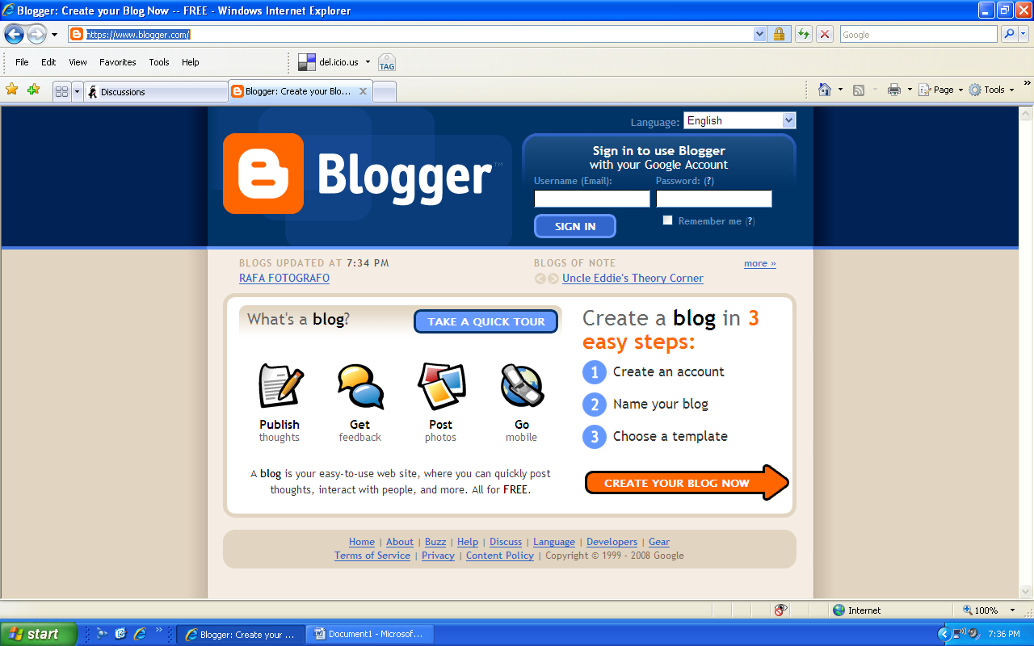
Click this arrow

Once you click the “Create Your Blog Now” button, the website will prompt you to create a Google username and password (blogger.com is associated with Google). If you already have one, you can click the link towards the top of the page to sign in. Otherwise, fill out the requested information to create your unique Google username and password. Once the information is entered, click the orange arrow at the bottom of the page to continue.

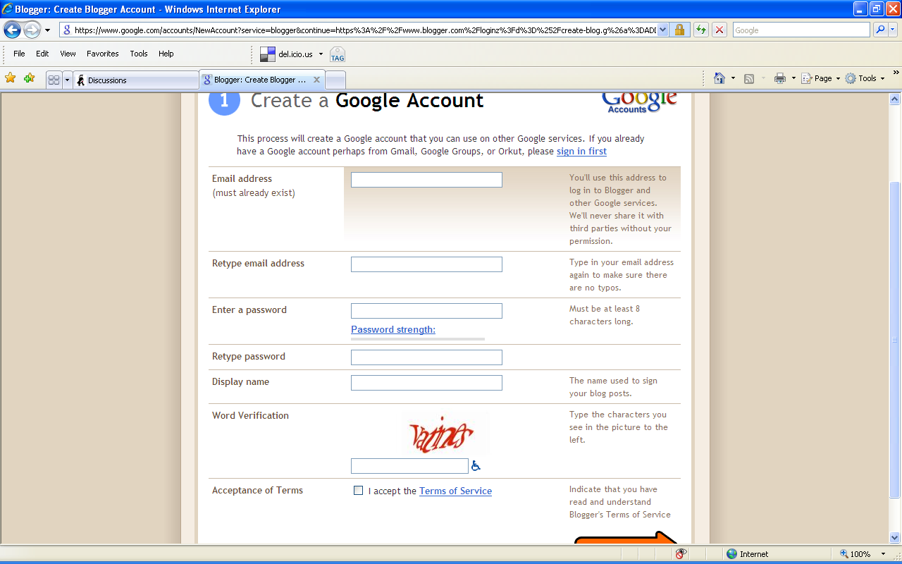
If you have a Google username, click the blue link to sign in.
Otherwise, fill out the requested information and click the orange arrow to create one.
The next step will prompt you to name your blog. Fill in the requested information and hit the orange arrow to continue.

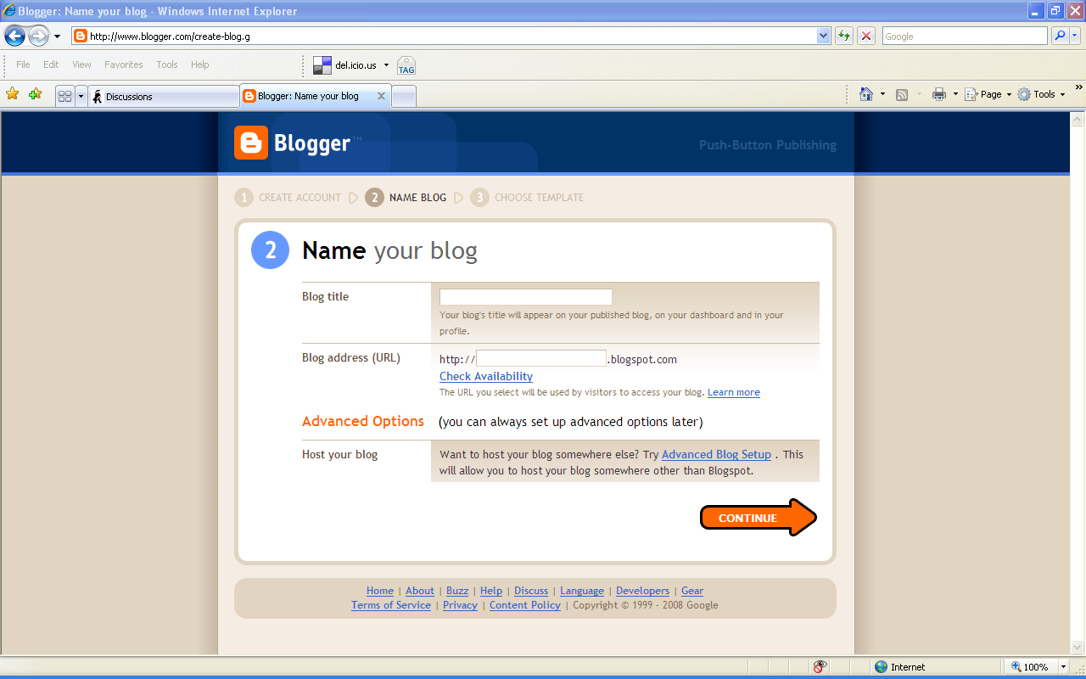
Make up a name for your blog and give it an address that will be easy to remember. Then, click the orange arrow to continue.

Finally, you will be asked to choose a template. Scroll through the available designs and choose your favorite by clicking the circle under the one you want. Then, click the orange arrow to continue. (Keep in mind that you can change your template at any time).

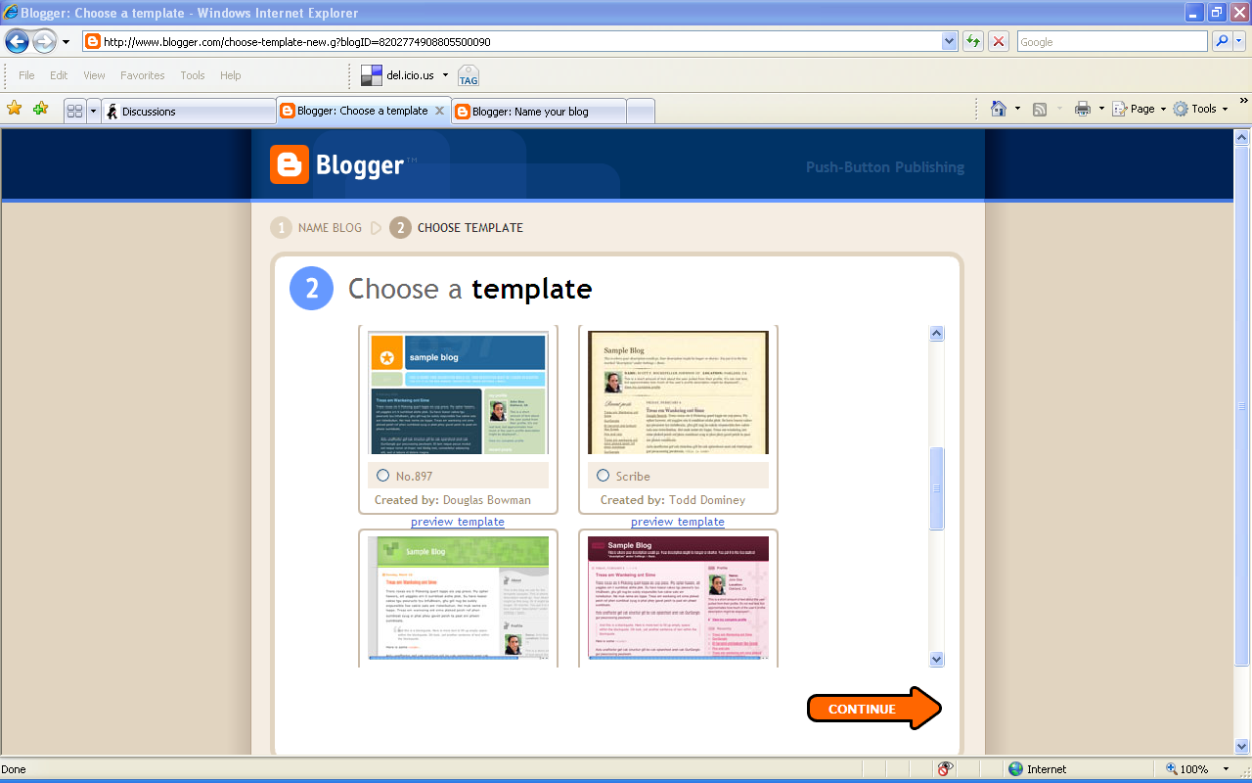
Click the circle for the template you want to use. Then, click the orange arrow to continue.

If you have done everything correctly, you should see the following screen indicating that your blog has been created:

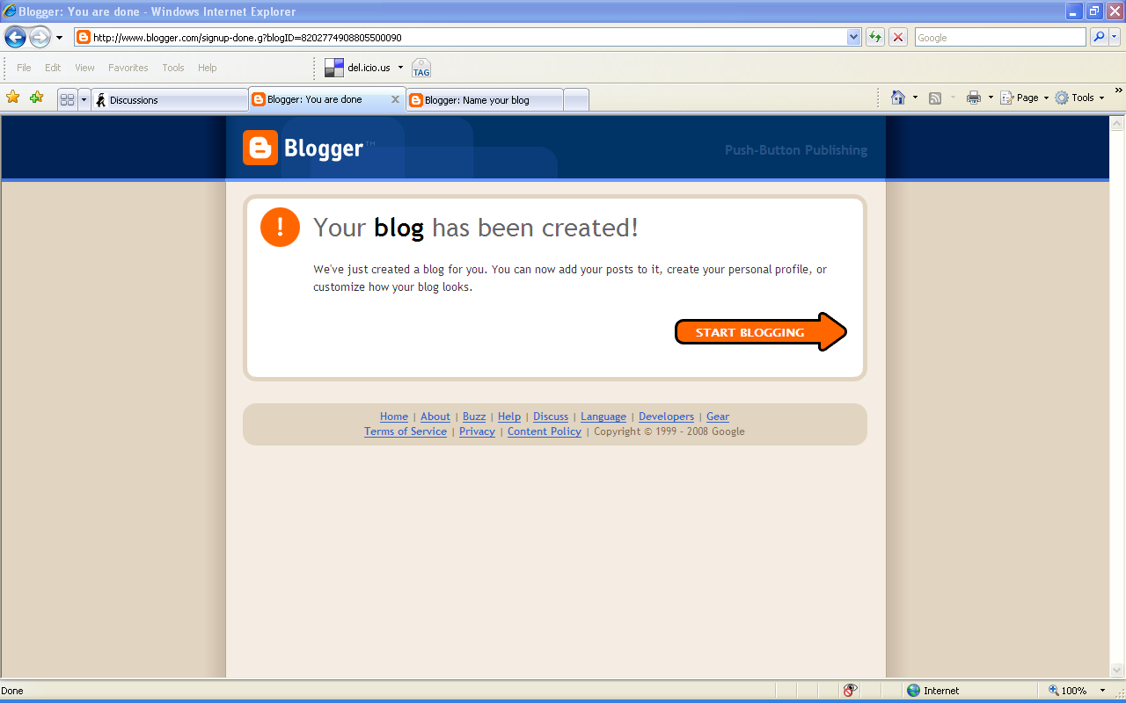
You are all set. Click the orange arrow to “START BLOGGING!!!”

Now that your blog has been created, you can post topics, class information, a calendar of events, or even class surveys. We will cover the specifics for adding these items (and more) during sessions 2-4 and our follow-up user group meetings. However, if you are feeling adventurous, do not be afraid to investigate the site on your own (all changes are made from the “Dashboard”). Additionally, please see the attached webliography of useful links for other tips and suggestions for getting the most out of your class blog.

WEBLIOGRAPHY OF USEFUL LINKS

https://www.blogger.com/start - This is the link to the main site for Blogger, where you will be setting up an account and logging in to edit and monitor your blog.

http://mrgallo.blogspot.com/ - This is the link to my classroom blog. Please feel free to visit it for ideas and inspiration.

http://tappedin.org/tappedin/ - Tapped In is “The online workplace of an international community of education professionals.” This link is where you will need to go to become a member and participate in the synchronous user group meetings.

http://www.teachersfirst.com/content/blog/blogbasics.cfm - This is the link to a helpful blog tutorial offered by teachersfirst.com. In addition, they offer many suggestions for blog topics and activities for students.

http://www.adrianbruce.com/blogging/blogging.htm - This is the link to the site of a talented blogger named Adrian Bruce. He offers plenty of interesting rationale and multiple ideas for effective blogging in the classroom.

http://mathmusings.blogspot.com/2006/01/safe-blogging.html - This is the link to a fellow educator’s blog on blogger.com. She discusses “safe blogging” and includes an impressive and useful blogging policy.

http://supportblogging.com/Links+to+School+Bloggers – This link is to a website that offers information on educational blogging and an extensive list of fellow school bloggers and links to their sites.

Any of these links should be able to assist you with your blogging. In addition, please make a note of any issues or positive experiences that you come across as you maintain and use your blog. These topics will be addressed during our monthly user group meetings. Finally, if you need assistance with anything related to your blog and would rather not wait until the monthly user group meeting, please feel free to e-mail me or visit my classroom. It would be my pleasure to offer any help that I can give!

PARTICIPANT FEEDBACK SURVEY
(To be completed after Session 4)

- What subject and grade do you teach?

- Please describe at least one assignment that you plan on using your blog for.

- Would you recommend this professional development series to other teachers? Why or why not?

- If you could change one thing about the way that the material was presented, what would that be?

- Please list any topics or issues that require clarification or that you would like to see addressed during our user group meeting.

REFERENCES

Barton, K., Boling, E., Castek, J., Nierlich, T., & Zawilinski, L. (2008, March). Collaborative
literacy: blogs and internet projects. Reading Teacher, 61 (6), 504-506.
Huang, C., & Liu, Y. (2005, March). Concerns of teachers about technology integration in the
USA. European Journal of Teacher Education, 28, 35-47.
Lachman, A., & MacBride, R. (2008, May). Capitalizing on emerging technologies: a case
study of classroom blogging. School Science & Mathematics, 108 (5), 173-183.
O’Hanlon, C. (2007, November). The teacher becomes the student. T H E Journal, 34 (11),
20-22.
Pack, T. (2006, April). Keeping cyberteens safe. Information Today, 23 (4), 37-39.

TF STANDARDS

By completing this assignment, the following TF standards will have been met:

Technology Facilitation Standard I. (TF-I)

Technology Operations and Concepts. Educational technology facilitators demonstrate an in-depth understanding of technology operations and concepts. Educational technology facilitators

TF-I.A. Demonstrate knowledge, skills, and understanding of concepts related to technology (as described in the ISTE National Educational Technology Standards for Teachers). Candidates:

- Assist teachers in the ongoing development of knowledge, skills, and understanding of technology systems, resources, and services that are aligned with district and state technology plans.
- Provide assistance to teachers in identifying technology systems, resources, and services to meet specific learning needs.

TF-I.B. Demonstrate continual growth in technology knowledge and skills to stay abreast of current and emerging technologies. Candidates:

- Model appropriate strategies essential to continued growth and development of the understanding of technology operations and concepts.

Technology Facilitation Standard II. (TF-II)

Planning and Designing Learning Environments and Experiences. Educational technology facilitators plan, design, and model effective learning environments and multiple experiences supported by technology. Educational technology facilitators:

TF-II.A. Design developmentally appropriate learning opportunities that apply technology-enhanced instructional strategies to support the diverse needs of learners. Candidates:

- Provide resources and feedback to teachers as they create developmentally appropriate curriculum units that use technology.
- Consult with teachers as they design methods and strategies for teaching computer/technology concepts and skills within the context of classroom learning.
- Assist teachers as they use technology resources and strategies to support the diverse needs of learners including adaptive and assistive technologies.

TF-II.B. Apply current research on teaching and learning with technology when planning learning environments and experiences. Candidates:

- Assist teachers as they apply current research on teaching and learning with technology when planning learning environments and experiences.

TF-II.C. Identify and locate technology resources and evaluate them for accuracy and suitability. Candidates:

- Assist teachers as they identify and locate technology resources and evaluate them for accuracy and suitability based on district and state standards.
- Model technology integration using resources that reflect content standards.

TF-II.D. Plan for the management of technology resources within the context of learning activities. Candidates:

- Provide teachers with options for the management of technology resources within the context of learning activities.

TF-II.E. Plan strategies to manage student learning in a technology-enhanced environment. Candidates:

- Provide teachers with a variety of strategies to use to manage student learning in a technology-enhanced environment and support them as they implement the strategies.

TF-II.F. Identify and apply instructional design principles associated with the development of technology resources. Candidates:

- Assist teachers as they identify and apply instructional design principles associated with the development of technology resources.

Technology Facilitation Standard III. (TF-III)

Teaching, Learning, and the Curriculum. Educational technology facilitators apply and implement curriculum plans that include methods and strategies for utilizing technology to maximize student learning. Educational technology facilitators:

TF-III.A. Facilitate technology-enhanced experiences that address content standards and student technology standards. Candidates:

- Use methods and strategies for teaching concepts and skills that support integration of technology productivity tools (refer to NETS for Students).
- Use and apply major research findings and trends related to the use of technology in education to support integration throughout the curriculum.
- Use methods and strategies for teaching concepts and skills that support integration of problem solving/decision-making tools (refer to NETS for Students).
- Use methods and strategies for teaching concepts and skills that support use of media-based tools such as television, audio, print media, and graphics.
- Use and describe methods and strategies for teaching concepts and skills that support use of distance learning systems appropriate in a school environment.
- Use methods for teaching concepts and skills that support use of web-based and non web-based authoring tools in a school environment.

TF-III.E. Use current research and district/region/state/national content and technology standards to build lessons and units of instruction. Candidates:

- Describe and identify curricular methods and strategies that are aligned with district/region/state/national content and technology standards.
- Use major research findings and trends related to the use of technology in education to support integration throughout the curriculum.

Technology Facilitation Standard IV. (TF-IV)

Assessment and Evaluation. Educational technology facilitators apply technology to facilitate a variety of effective assessment and evaluation strategies. Educational technology facilitators:

TF-IV.A. Apply technology in assessing student learning of subject matter using a variety of assessment techniques. Candidates:

- Model the use of technology tools to assess student learning of subject matter using a variety of assessment techniques.
- Assist teachers in using technology to improve learning and instruction through the evaluation and assessment of artifacts and data.

TF-IV.B. Use technology resources to collect and analyze data, interpret results, and communicate findings to improve instructional practice and maximize student learning. Candidates:

- Guide teachers as they use technology resources to collect and analyze data, interpret results, and communicate findings to improve instructional practice and maximize student learning.

TF-IV.C. Apply multiple methods of evaluation to determine students' appropriate use of technology resources for learning, communication, and productivity. Candidates:

- Assist teachers in using recommended evaluation strategies for improving students' use of technology resources for learning, communication, and productivity.

Technology Facilitation Standard V. (TF-V)

Productivity and Professional Practice. Educational technology facilitators apply technology to enhance and improve personal productivity and professional practice. Educational technology facilitators:

TF-V.A. Use technology resources to engage in ongoing professional development and lifelong learning. Candidates:

- Identify resources and participate in professional development activities and professional technology organizations to support ongoing professional growth related to technology.
- Disseminate information on district-wide policies for the professional growth opportunities for staff, faculty, and administrators.

TF-V.B. Continually evaluate and reflect on professional practice to make informed decisions regarding the use of technology in support of student learning. Candidates:

- Continually evaluate and reflect on professional practice to make informed decisions regarding the use of technology in support of student learning.

TF-V.C. Apply technology to increase productivity. Candidates:

- Use a variety of distance learning systems and use at least one to support personal/professional development.
- Use instructional design principles to develop hypermedia and multimedia products to support personal and professional development.
- Select appropriate tools for communicating concepts, conducting research, and solving problems for an intended audience and purpose.
- Use examples of emerging programming, authoring or problem solving environments that support personal/professional development.
- Set and manipulate preferences, defaults, and other selectable features of operating systems and productivity tool programs commonly found in P-12 schools.

TF-V.D. Use technology to communicate and collaborate with peers, parents, and the larger community in order to nurture student learning. Candidates:

- Model the use of telecommunications tools and resources for information sharing, remote information access, and multimedia/hypermedia publishing in order to nurture student learning.
- Communicate with colleagues and discuss current research to support instruction, using applications including electronic mail, online conferencing, and web browsers.
- Participate in online collaborative curricular projects and team activities to build bodies of knowledge around specific topics.
- Design, develop, and maintain Web pages and sites that support communication between the school and community.

Technology Facilitation Standard VI. (TF-VI)

Social, Ethical, Legal, and Human Issues. Educational technology facilitators understand the social, ethical, legal, and human issues surrounding the use of technology in P-12 schools and assist teachers in applying that understanding in their practice. Educational technology facilitators:

TF-VI.A. Model and teach legal and ethical practice related to technology use. Candidates:

- Develop strategies and provide professional development at the school/classroom level for teaching social, ethical, and legal issues and responsible use of technology.
- Assist others in summarizing copyright laws related to use of images, music, video, and other digital resources in varying formats.

TF-VI.B. Apply technology resources to enable and empower learners with diverse backgrounds, characteristics, and abilities. Candidates:

- Assist teachers in selecting and applying appropriate technology resources to enable and empower learners with diverse backgrounds, characteristics, and abilities.
- Identify, classify, and recommend adaptive/assistive hardware and software for students and teachers with special needs and assist in procurement and implementation.

TF-VI.C. Identify and use technology resources that affirm diversity. Candidates:

- Assist teachers in selecting and applying appropriate technology resources to affirm diversity and address cultural and language differences.

TF-VI.D. Promote safe and healthy use of technology resources. Candidates:

- Assist teachers in selecting and applying appropriate technology resources to promote safe and healthy use of technology.

TF-VI.E. Facilitate equitable access to technology resources for all students. Candidates:

- Recommend policies and implement school/classroom strategies for achieving equitable access to technology resources for all students and teachers.

Technology Facilitation Standard VII. (TF-VII)

Procedures, Policies, Planning, and Budgeting for Technology Environments. Educational technology facilitators promote the development and implementation of technology infrastructure, procedures, policies, plans, and budgets for P-12 schools. Educational technology facilitators:

TF-VII.A. Use the school technology facilities and resources to implement classroom instruction. Candidates:

- Use plans to configure software/computer/technology systems and related peripherals in laboratory, classroom cluster, and other appropriate instructional arrangements.
- Model integration of software used in classroom and administrative settings including productivity tools, information access/telecommunication tools, multimedia/hypermedia tools, school management tools, evaluation/portfolio tools, and computer-based instruction.
- Utilize methods of installation, maintenance, inventory, and management of software libraries.
- Use and apply strategies for troubleshooting and maintaining various hardware/software configurations found in school settings.
- Use network software packages used to operate a computer network system.
- Work with technology support personnel to maximize the use of technology resources by administrators, teachers, and students to improve student learning.

TF-VII.B. Follow procedures and guidelines used in planning and purchasing technology resources. Candidates:

- Identify instructional software to support and enhance the school curriculum and develop recommendations for purchase.
- Discuss and apply guidelines for budget planning and management procedures related to educational computing and technology facilities and resources.
- Apply current information involving facilities planning issues and computer related technologies.
- Suggest policies and procedures concerning staging, scheduling, and security for managing computers/technology in a variety of school/laboratory/classroom settings.
- Use distance and online learning facilities.

TF-VII.C. Participate in professional development opportunities related to management of school facilities, technology resources, and purchases. Candidates:

- Support technology professional development at the building/school level utilizing adult learning theory.

Technology Facilitation Standard VIII. (TF-VIII)

Leadership and Vision. Educational technology facilitators will contribute to the shared vision for campus integration of technology and foster an environment and culture conducive to the realization of the vision. Educational technology facilitators:

TF-VIII.A. Use the school technology facilities and resources to implement classroom instruction. Candidates:

- Discuss and evaluate current research in educational technology.

TF-VIII.B. Apply strategies for and knowledge of issues related to managing the change process in schools. Candidates:

- Discuss the history of technology use in schools.

TF-VIII.C. Apply effective group process skills. Candidates:

- Discuss the rationale for forming school partnerships to support technology integration and examine an existing partnership within a school setting.

TF-VIII.D. Lead in the development and evaluation of district technology planning and implementation. Candidates:

- Participate in cooperative group processes and identify the processes that were effective.
- Conduct an evaluation of a school technology environment.
- Identify and discuss national, state, and local standards for integrating technology in the school environment.
- Describe curriculum activities or performances that meet national, state, and local technology standards.
- Examine issues related to hardware and software acquisition and management.

TF-VIII.E. Engage in supervised field-based experiences with accomplished technology facilitators and/or directors. Candidates:

- Examine components needed for effective field-based experiences in instructional program development, professional development, facility and resource management, WAN/LAN/wireless systems, or managing change related to technology use in school based settings.

